Berlin
Destination Assessment
Executive Summary Report

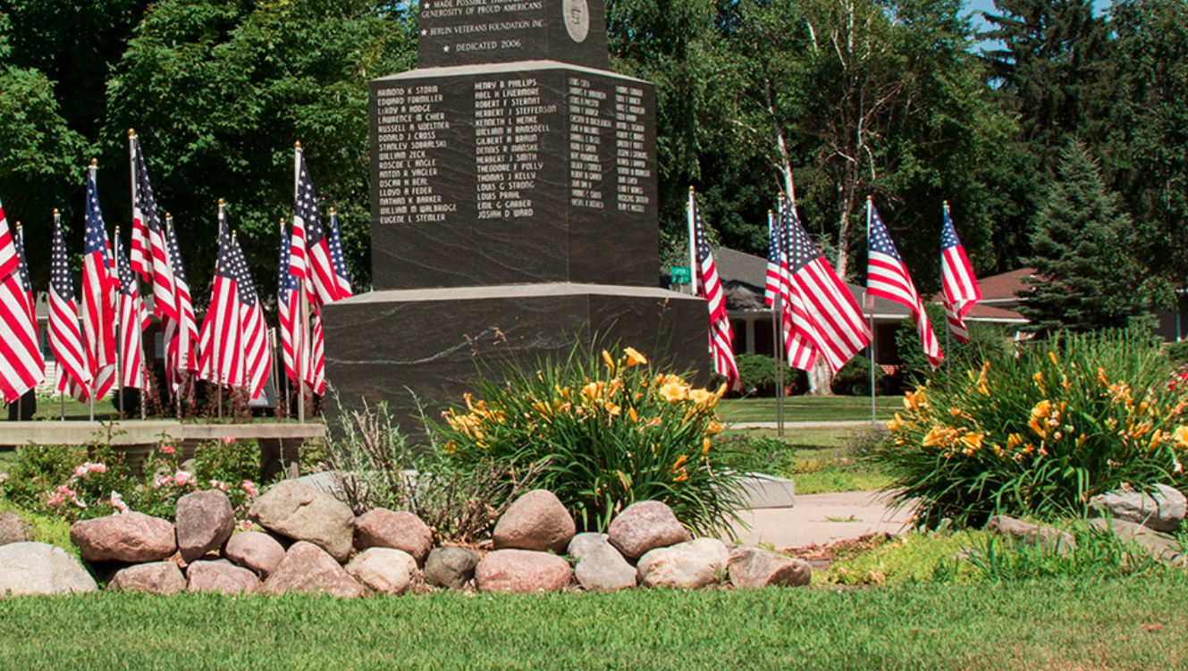

Fall 2019

Acknowledgements:
The Berlin Destination Assessment was conducted as a joint project between the Wisconsin Department of Tourism and the City of Berlin with support from:

Wisconsin Department of Tourism Strategic Mission

The Wisconsin Department of Tourism’s mission is to market the state as the Midwest’s premiere travel destination for fun. By executing industry-leading marketing programs, providing reliable travel information and establishing strategic partnerships, we will play a significant role in delivering exceptional customer service and generating greater economic impact and jobs for Wisconsin.

Lindsey Kemnitz, City of Berlin - Community Development Director
Deana Ceman, Violet&Company, Aurora Manufacturing
Janet Briesch, The House on Park
Tricia Clasen-Prellwitz, Goodrich Furniture
Julie Boeck, Mascoutin Transportation Inc
Mary Kubiak
Tom Wilson, First Weber Realtors
Tom Yankowski, Eskimo Comfort
Dick Schramer, City of Berlin Mayor
Ron Harke, Alderperson - 6th Ward
Andi Rogers, The Dandelion Farm
Deidre Sauer, The Dandelion Farm
Kristina Boeck, Baked Cakes by Design
Jodie Olson, City of Berlin - City Administrator
Pat Bartol
Bob Malchetske, Farmers & Merchants Bank
Todd Huggins, Badger Mining
Faye Gelhar, Hamiltons
Roberta A. Erdmann, Alderperson
Sarah Lachapell, Aurora Manufacturing
Pam Mork, Theda Care Medical Center
Phillip Pik, All In One Insurance Group
Richard Fortnum, retired
Sharon Fortnum, retired
Ty Gonyo, Berlin Journal Newspapers
Daniel Hoppa
Sara Nigbor, Senior Center / Parks and Rec
Josh Nigbor, Alderperson
Benjamin Cloyd, Riverside Coffee Company
Joel Bruessel, MotivAction Education

Assessment Summary Contents:
Overview of Berlin - 4
History of Berlin - 5
Destination Assessment Process - 6
Visitor, Resident and Stakeholder Surveys Overview - 8
Resident and Stakeholder Survey Responses - 8
Visitor Survey Responses - 21
Destination Asset Summary - 31
Top Berlin Assets - 32
Competitive Overview: Win, Lose, Draw - 33
Strengths, Weaknesses, Opportunities, Threats - 34
Berlin Development Opportunities - 35
Mission and Vision Summary - 36
Recommendations - 37
Credits and Acknowledgments - 39
Attachments - 40

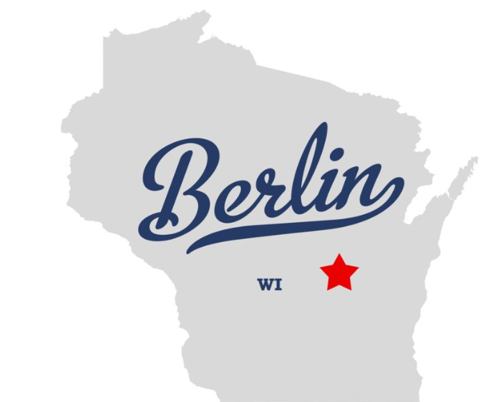

Assessment report prepared by:
Andrew Nussbaum, Wisconsin Department of Tourism

Berlin, Wisconsin: Overview
Nestled along the Fox River, only 20 minutes west of Oshkosh, a drive to Berlin will truly offer ample opportunities to relax and refresh in a community that cares. Whether your interests are golf, camping along the Fox, a family day at the Aquatic Center, or maybe just a walk along the Riverside Park River Trail, you will find Berlin is a great place to visit, live, work and play.

Golf at the beautiful Mascoutin Golf Course located just 8 minutes from Green Lake, 27 well-groomed holes await to challenge golfers of all abilities.

Berlin’s accessibility to the Fox River provides opportunities for a leisurely day of canoeing, kayaking, boating or fishing. One of the few rivers in the world that runs north, the Fox is truly a sport enthusiast’s paradise. From Berlin, boat anywhere upstream by lockage through the renovated Eureka Locks, locally funded and operated by the Berlin Boat Club. Whether launching your boat at Berlin’s Riverside Park or the Berlin Locks there is no launch fee!

Berlin’s Riverside Park boasts one of the best campgrounds in the county featuring waterfront sites, electricity, fire pits, baseball fields, playgrounds, disc golf, volleyball courts (and dump station). Enjoy the serenity of the Fox or fish from your campsite. A short walk to Berlin’s historic downtown will delight the inquisitive shopper or diner, as well as the lover of Wisconsin history.

Wildlife abounds as you bike, walk or run the Mascoutin Trail. Twelve miles of paths meander through three counties. With the trail head starting at Berlin, a quiet ride gives you the opportunity to view deer, geese, Sandhill cranes and other critters as you bike to Ripon and Green Lake. Birdwatchers delight in tracking local and migrant species alike.

Summer events for the whole family include the Berlin Fox Festival, Independence Day Berlin Style, Bugle Mouth Bass Fishing Tournament, the Berlin Boat Club Corn Roast and Street Cruzers Car Show.

As the year comes to a close, the Christmas season is met in Berlin with “The Biggest Little Parade in the Valley”. Kick off the joyous Holiday Season with our lighted parade entries and marching bands. Witness the magic as over 100 trees are lit in beautiful Nathan Strong Park. Outdoor winter enthusiasts can enjoy some of the best snowmobiling trails in the county, riding all the way up the Fox River.

Lastly, when cabin fever comes your way it’s time to get out, shake off the winter blues and partake in the Wine and Beer Extravaganza. Quench your palate on wines from around the world or satisfy your taste buds on fine cuisine from local and area restaurants.

Information courtesy of Berlin Chamber of Commerce https://berlinchamber.net/about-berlin/

Green Lake County Economic Impact Data 2018
Ranked #48 / 72 Counties

Direct Visitor Spending (in Millions) |  | Total Business Sales (in Millions) |  | State and Local Taxes (in Millions) |  | Employment (Actual) |  | Total Labor Income (in Millions)
2017 | 2018 | 2017 | 2018 | 2017 | 2018 | 2017 | 2018 | 2017 | 2018
$39.3M | $42.8M | $60.2M | $64.6M | $5.6M | $5.9M | 739 | 758 | $16.6M | $17.5M

History of Berlin
The City of Berlin straddles the Fox River for several miles. Founded in 1847 by Nathan Strong, its natural resources and location on the river contributed to its rapid growth. Strong and his colleagues were part of the Fourierite movement located in Ceresco (later the City of Ripon). Disenchanted with the movement Strong decided to strike out on his own and establish a new settlement. By 1850 there were 250 residents, most coming from the New England states. At that time only land on the east side of the river was available, the west side was still “Indian Country.” The Native Americans ceded their claim in late 1850 and it was opened for settlement.
The railroad came in 1857 opening another avenue for travel for the residents. In that same year the city was incorporated.
Berlin grew rapidly because of its location and of the goods and services its businesses could provide.
When Green Lake County was formed, it served as the county seat for a time.
Wisconsin’s commercial cranberry industry was started in the Berlin area. Her stone quarries provided jobs and state-wide reputation and brought immigrants from Scotland, Wales, Poland, and Italy to work in those quarries. From the mid-1860’s to the 1990’s Berlin was known as “the fur and leather city” because of the multiple businesses located here. The first milk condensery factory in the mid-west was started in the early part of the 20th century by the Carnation Co.
Today Berlin is home to several well-known manufacturers such as Magnum Power Products, producers of self-contained light towers and generators; Wisconsin Spice, servicing the food industry; and RAJ who creates and supplies many of the professional and college ball team uniforms, to name a few.
Information courtesy of Berlin Historical Society. https://berlinareahistoricalsociety.com/

What Does Success Look Like Here?
To effectively plan the tourism development strategy, it is necessary to bring together the right people who can plan what activities, events or attractions will appeal to visitors and increase expenditures. The outcome of such a process sets the stage for product growth and establishes the platform for marketing plan development. It is important to answer the following questions:
- Who are your customers and what do they say is important to them?
- Do you have those assets and experiences, or do you need to develop them?
- Is there a coordinated effort between your tourism and economic development programs?
- Are your stakeholders on board and do they understand the power of tourism and the contributions it makes to local and state economies?

Destination Assessment Process

Communities that believe they can compete for visitors should be commended for the vision to diversify their economies. In terms of job growth, the travel and tourism industry are one of the fastest growing industries in the new economy. And, these are jobs that can very rarely be exported outside the borders of the badger state, much less the nation.
The Wisconsin Department of Tourism offers tourism partners a process designed to find the best path for maximizing strengths, appeal to visitors, and the development necessary to increase the impact of visitor spending on the local economy and grow jobs.
The process begins by engaging a municipality or an independent not-for-profit agency such as a Destination Marketing Organization (DMO), Convention & Visitors Bureau (CVB), Chamber of Commerce, Economic Development Corporation, Sports Commission or Arts Council. These entities have the resources to launch the process and the administrative ability to keep it on track.

1) Lead Organization/Municipality to Assign Task Force
The first step in the Destination Assessment Process is to assign a Task Force to take the lead in the deliberations that will ultimately establish a framework for enhanced destination marketing and development.
The Task Force should have some individuals with hospitality-specific backgrounds, but other stakeholders in the community are vital as well. The Task Force should be made up of hoteliers, restaurateurs, retailers and attractions; and, individuals from the arts community, agriculture, finance, healthcare, manufacturing, media and education. While every community is different, the optimum size for such a group is 13-20. This can be scaled back for very small destinations.

2) Lead Organization Gathers Perception Research Data
The lead organization embarks on a fact-finding mission to thoroughly understand how the community perceives itself and what visitors think. This two-pronged approach affirms that there is a base from which an effective tourism strategy can be launched and that the community would be supportive of welcoming more visitors.
The Department staff guides the lead organization through available primary marketing research, existing economic impact research and how to perform perception research through intercept surveys and online vehicles.
Once the data has been gathered, the Task Force convenes to analyze the findings and develop a case that increasing visitation to the community could significantly enhance the local economy and job growth.

3) Perform a Comprehensive Inventory of Destination Assets
Probably the most important facet of a Destination Assessment is the compilation of a comprehensive inventory of assets. With a complete understanding of what the destination offers a visitor, the destination can maximize those assets and plan for development of the missing pieces.
The goal is to identify every asset that a visitor to the community could find interesting enough to visit or utilize.

4) Analyze all Research
Once the entire intelligence gathering has been completed by the Assessment Task Force, the analysis process begins and includes:
• Destination Strengths, Weaknesses, Opportunities and Threats
In addition, the Task Force performs an analysis of its competitors. From the list of competitors, the Task Force then assess whether their community wins, losses or draws in head-to-head competition. As every destination has several aspects of appeal to visitors, the Task Force breaks the comparisons into several experiences.

5) Identification of Destination Vision
Once the community’s compelling strengths have been identified and the research data analyzed, the Task Force identifies a destination vision to drive future initiatives. Short of developing a brand identity, this process establishes the goals toward which the destination will strive.

6) Identification and Prioritization of Potential Destination-enhancing Development Projects
With a destination vision established, the Task Force can begin to identify and prioritize the types of initiatives that will propel the destination forward in its desire to expand its visitor economy.

Berlin Destination Assessment Visitor, Resident and Stakeholder Surveys
Common Themes in Resident and Stakeholder Perceptions
The challenge is to differentiate Berlin’s strengths from the competition. The first step is to find out what locals think. There were 366 total survey participants, with 352 completing the entire survey.
- 97% of respondents support finding ways to attract visitors to Berlin.
- Top positive responses included mention of parks (17.95%), the Fox River, shopping, restaurants, and events.
- 8.55% of responses stated “Nothing Would Encourage a Visit”
Question 1 : If you did not live here, what about this community would encourage you to visit?
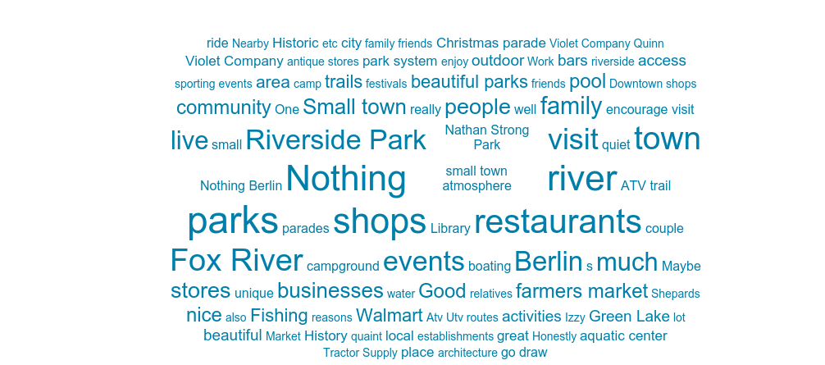

The following is representative of the recorded responses:
- Parks, school system, healthcare system
- Small town, Parks
- Do not come to 4th of July celebration - I knew 1 picnic table of Berlin people - 400 of scary wild people that have moved to town - no wonder this City can't support Events!
- Parks and Walmart
- The Parks, a parade or if invited to a wedding at the City Inn.
- Not Much!
- Variety of restaurants, stores, general appearance of the community
- None
- Fishing-Outdoor activities
- Our beautiful Parks! The River
- Beautiful Parks - we need to clean up junk houses entering town, completely turns you off for community
- Fox River, Car Show, Tractor Steam Show
- I have lived here most of my life - the town used to be blooming. Now its run down and empty. Very Sad.
- Maybe the parks, Christmas parade & boat club picnic and car show
- Parks, Fox River and main street architecture
- Not much any more
- The Parks, the Catholic Church, Hamilton's Ladies, Bellismo’s and maybe Jeff's. Generally, do not attend events out of community so go to the things done locally.
- The parks and river - small town friendliness
- The Parks, Hospital and Schools
- Hamilton's - Lady Bug - Frank's Meats
- Nothing, we need a good grocery store! A lot of money is going out of town for groceries daily. Our main street is about dead.
- Reasonably priced homes along the Fox River to possibly live - To "Visit" - Not much appeal in all Honesty!!
- Fox River (Boating, Fishing, Parks & Flowers), interest in History, museum, churches, library, school system, Nursing Homes and Assisted Living Facilities
- Relatives and Restaurants
- More festivals and an improved Main Street. So much potential but needs beautification and occupancy. I understand there’s some plans in the works to spruce up the riverfront. I would support those efforts.
- Visit relatives and restaurants
- A couple of the stores and restaurants. Sporting event.
- Belissimo, Violet and Company/Quinn's, Las Brasas, the fox river, the outdoor pool, high school sporting events.
- The campground/park system. Walmart, Clem's Bars.
- The beautiful parks and Fox River; Farmer's Market; Amazing snowmobile trails in the winter; Car Show; Berlin Conservation Club outings/events
- Concerts in the Park and we think a makeshift bar should be offered while listening to music. have the music/entertainment perform longer. Difficult to get there and get settled after work before it is over.
- If there was great shopping, unique shops, cute shops, cute storefronts, nice places to eat.
- Specialty businesses such as Russell Moccasin, R & M Motors, Bohn Implement, Mike's Bike Shop, Goodrich Home Furnishings, Bellisimo's, Hamilton's Clothing, Chinese Restaurant, United at 4 Corners, Cheese house on Hwy. 21, 2 very nice car dealerships, Moriarty Refrigeration, Kitz & Pfeil Hardware, Tractor Supply store in Mall, Nail Shop in Mall, Violet & Company. The various vintage shops also draw certain folks who enjoy that type of style.
- The Fox River for fishing, White River Marsh Wildlife Area for hunting and nature observation, area lakes for fishing, area golf courses. The Berlin city parks are worth visiting.
- The park or the river
- A couple nice restaurants. Campers enjoy visiting at the park. The aquatic center can be an attraction to nearby visitors. Wal-Mart, Tractor Supply and Kitz & Pfeil are a very nice trio of stores that attract a number of nearby visitors. Other than that, there is really not much to attract a tourist type visitor. The river itself is not sufficiently exploited in the downtown area. If there were more restaurants, bars, stores that had a focus on the river, I think those things would be popular for potential tourists. For example, Izzy's has some sort of dock, but no real eating area overlooking the river and their entire river area needs a lot of maintenance. On the other side of the river from Izzy's, that has great potential, but nothing ever happens.
- Other than the fact that there is family here, we probably would not visit here.
- The Library and Walmart
- Not much
- Fishing or boating on the Fox River
- The parks and the charm of the historical buildings that are still in use

Question 2 : From a visitor's perspective, what are this community's most attractive assets?
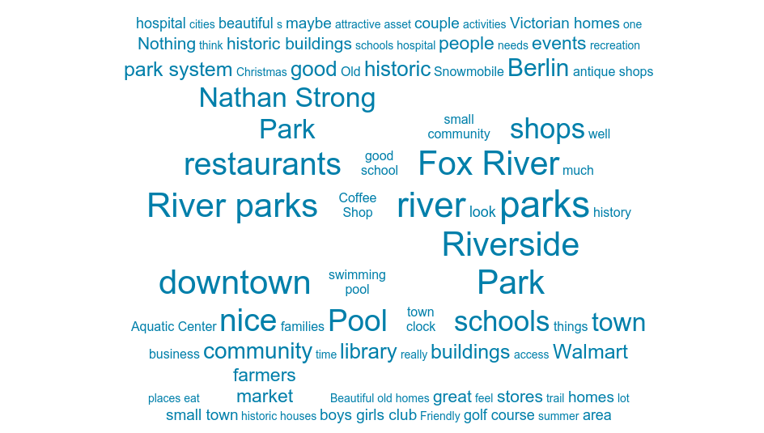

The following is representative of the recorded responses:
- Parks, beautiful old homes
- River and parks
- We have a very rich Boys & Girls Club - but no one from this City uses it. They are all tough kids that have been moved in from who knows where - scary place.
- River and lots of Parks. Other items might be a citywide bike day to go along the River and down to Ace Hardware, O'Reilly Automotive and Walmart. This could be combined with other events.
- The Parks are well kept, possibly the pool for youngsters in the summer.
- River & Parks
- River, camping site & outdoor pool
- None
- Live here
- Parks - Antique shops to browse through
- Fox River
- Probably the Parks, nothing much else here anymore.
- Parks, Schools and Hospital
- Parks, attractive and active senior center, flower baskets on main street
- Victorian Homes
- Schools, Library, Senior Center, Hospital, Churches, nice and attractive Park system. Amazing golf course - could use an eatery venue there. We need to support our own. Give local retailers and service folks a chance.
- The parks and river - small town friendliness. Close to Oshkosh/Appleton. Beautiful churches, golf course and new schools
- The beautiful Parks
- Our River and Parks system. Some good eating places, place to camp and fish and walk or hike - boat.
- Fox River access and Recreational Trails
- Parks, Restaurants and Antique Stores
- Shepard's drive in and the parks
- Potential assets are a vibrant yet quaint Main Street and more festivals/attractions.
- Parks, Restaurants, Antique Show
- A couple of the stores and restaurants. Our park system is very nice, but I don't think it is overtly better than other towns'. Our athletic facilities are superb, so if we can get more sports tournaments in town, that helps some of our businesses as well as potentially introduces visitors to our town. Our school system in general is usually mentioned as a positive. We have a hospital and nice elderly care centers (Juliet Manor and Patriot Place). A ton of churches to choose from.
- same answers as #1. I also get a lot of comments from visitors on our trees in the park at Christmas, our parade and how lucky we are to have the river. I know our antique shops and Shepards attract visitors too.
- Shepards Drive-In, Berlin Aquatic Center, Violet & Co., Riverside Coffee, Ladybug
- Nathan Strong Park ...maybe
- The park system. Outdoor pool, rec department and programs.
- Parks; River; Snowmobiling; and see #1 response. Berlin does and has some great resources and events.
- Riverside Park and East side Park.
- Friendly people, Nice park system, Victorian Homes on Park Avenue, Beautiful churches, Business owners that go over and above to serve the customers and make them happy customers. Very good school system, Excellent Library, Berlin Senior Center, Banquet and dance hall facility - City Inn, 2 local banks that care about their customers and will try their best to help, them, Nice floral/gift shop, Hospital with wonderful doctors and nurses who care about the patient, dentists and eye doctors to serve residents. Fourth of July event in park and Music in the Park and Farm market during summer months. The Fox River and the Berlin Boat Club, the snowmobile trails and the Berlin River Riders Snowmobile Club both promote our area's outdoor assets.
- Berlin's city park system along the river. Boys & Girls Club. Swimming pool. Most everything else is out of town.
- Probably the river and the parks.
- Our friendliness. Small community, knowing your neighbor.
- The river, the parks & camping, but there is not much to do in Berlin while you're here.
- The parks are nice. Nathan Strong Park looks great during Christmas with all of the Christmas lights and is great for families to walk through.
- Nathan Strong Park. The Fox River
- River & people
- Farmers Market, Christmas trees in park, Historic buildings, restaurants,
- River
- Fairly Safe, friendly community, good schools, library and boys & girls club
- Good schools and nice library
- People are friendly. Library is good one with friendly staff.
- river navigation, good places to eat and drink close to river
- Riverside Park
Question 3 : What are this community's greatest weakness in being able to attract visitors?

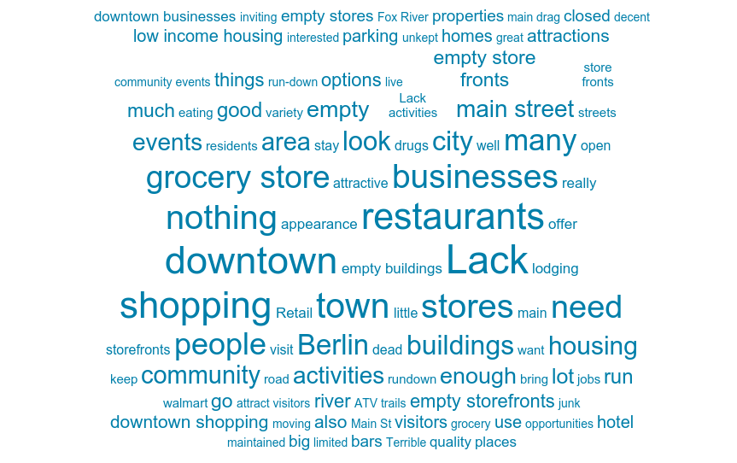
The following is representative of the recorded responses:
- Ugly downtown with empty stores, unkept store fronts, no grocery store, run down properties throughout community
- Lack of stores to shop. especially grocery. WALMART. cleaning
- Wonderful little town - clean-restaurants, cute shops, activities and events - All Gone! Good paying jobs are not here - no health or exercise programs - No Grocery Stores!!
- We no longer have a city theme. Years ago it was the Fur & Leather City. Ripon had Cookie Daze, we should have something like accordion days to promote polka music or photo days to promote photography.
- There is really nothing downtown and it's very shabby and run-down. Nothing but a super store that only attracts quick shopping & drives out other stores.
- As a person drives into Berlin, they see ran down homes. Getting to main street, they would see empty store fronts, exception being Hamilton's or if they go a block, Violet & Co. Also, Bellismo.
- Downtown area is run down in appearance, unkept properties, lacking a specific "niche" to draw visitors , yet remain affordable for local residents
- All the bad homes let go and stores
- Housing that is not for low income. Transportation - within the City & to outside areas. Get a grocery store
- We need a restaurant that caters for breakfast with good food. Not overly salty and taking an hour for eggs & toast. Visitors want to eat and be on their way.
- No real draw other than Fox River and Hospital
- Downtown stores, lack of something that would make it a destination, poor streets
- Condition of city streets, empty stores, lack of grocery stores, store fronts don't look inviting/alive or interested in having visitors.
- Poor pothole streets run down homes and empty and run-down stores.
- No manufacturing opportunities - no good paying jobs. No stores - Grocery Store. Houses not taken care of - Trashy. No good housing - too many low income
- Clean up residential properties and business properties
- No Retail, Grocery store, dry cleaners, bakery or children's clothing store (not interested in low crap from Walmart)
- Not enough shops and not a good grocery store!
- UNWILLINGNESS OF PEOPLE WORKING TOGETHER! And the junky/run-down look of most of the community - So Sad!
- Old rental store fronts that need repair and paint. Residential neighborhoods that have I DON'T CARE HOW IT LOOKS ATTITUDE!
- lack of businesses in the downtown district and lack of community events
- Lack of energy downtown. The buildings, sidewalks and infrastructure have great potential but need rejuvenated.
- -
- Lack of quality housing. The look of some of the housing and storefronts on main drags in the city. Only a couple classy restaurants. Lack of things that young people want - microbrewery or winery. A population that seems to be weary of "outsiders." A lack of coordination between our businesses and between our businesses and the city.
- We don't have a ton of options. We have the beautiful Mascoutin trail, but there's not a great incentive for people to start or end here. A really cool restaurant or beautiful park at the start of the trail would invite more people to STAY here, for example. We don't have a hotel for visitors to stay.
- Downtown needs revamped - it's the main thoroughfare through Berlin and needs a more modern look/feel, new businesses, etc.
- Downtown hasn't grown with the times. Antique shops were out long ago. City doesn't enforce building codes and keeping up maintenance downtown or homes in town. There aren't business's with well-paying jobs. The people that have come here now are Welfare people getting hand outs and the City shows it.
- TOO MUCH DRUGS! Too many low-life drug users! Look in the Berlin Journal...if there's 10 incidents in the police report, 9 of them are drug related. Get these losers in jail or out of Berlin!!!
- The appearance of Berlin looks rundown in many areas - make homeowners/landlords clean up their property. We need a logo for our city and use that to our advantage. If it is the river - let's use the parks/river to set us apart from area communities.
- Empty storefronts. Too many resale shops. Too many residential homes that have too much junk in their yards and the homes are not kept up.
- This is the saddest downtown/mainstreet in the area. The number of empty store fronts shouts- no one wants to be here. Downtown poorly lit at night. Few places for visitors to eat. Few accommodations for anyone wanting to stay here to hunt or fish. No other attractions, no interesting shopping.
- The slum housing on Broadway and Huron
- Not much for shopping-you can't count Walmart as destination shopping. No matter which direction you come into town, the roads are in horrible shape and the houses all look like what they are-slumlord rentals.
- Residents not shopping locally. Businesses closing. Too many empty stores downtown.
- It is not a very attractive, well maintained city and needs a major face lift. There are very few shopping and eating sites. I think one of the reasons that so many businesses, particularly restaurants, fail in Berlin is the lack of parking. Even the special events have felt lackluster in the past few years.
- There isn't much of anything to do, places to visit, many restaurants to try. We are stuck in our old ways and do not take golden opportunities to attract quality visitors. If I'm visiting the area, I wouldn't stay in Berlin. I'd probably be hard pressed to even stop to be honest.
- There is nothing of substantial interest to attract visitors to Berlin.
- Boaters are afraid of the fox
- No big events like country USA, Princeton flea market
- More restaurants, nice sit down and family friendly
- No grocery store, lack of things to do- concerts, cultural events
- Empty storefronts
- A lot of empty storefronts, bad restaurants, no grocery store besides Walmart.
- Lack of restaurants, dull/dark storefronts, lack of hobby stores, if on river, no good easy to access docks close to main street
- Lack of activities and nothing but bars and antique shops.
- Most shops are open 9-5 Monday-Friday.
- I didn't notice any downtown cafe's or restaurants for lunch. A craft brewery would draw people in as well
- Terrible road conditions, lack of fast food options, deteriorating buildings, to many junk stores downtown, downtown business hours are not convenient for working families.
- Lack of enough young people and good shopping
- Nothing big or eye drawing and the roads suck

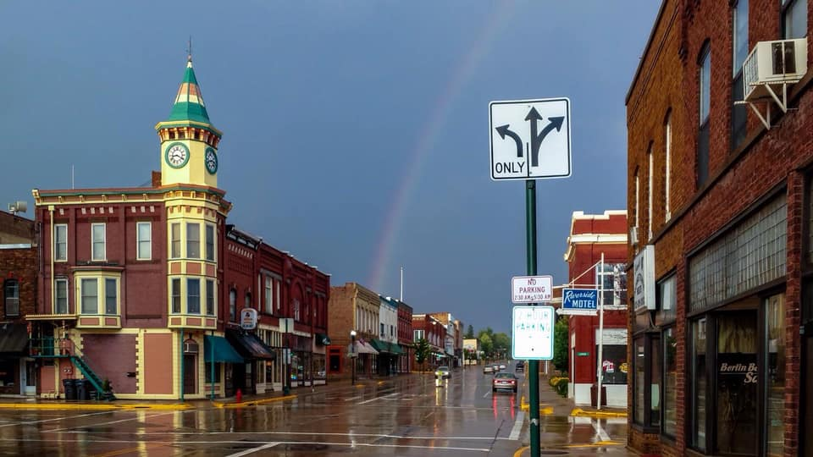
Tracy Rhodes - Klawitter's Photos
Question 4 : What addition to the community would make it more attractive to visitors?
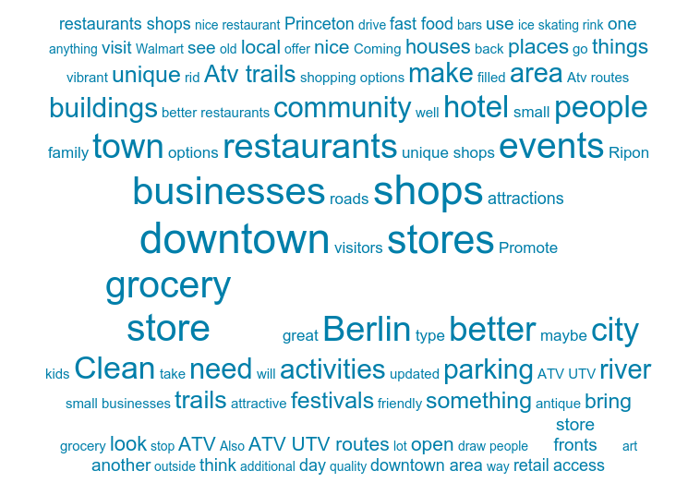

The following is representative of the recorded responses:

- Grocery store, clean up downtown, force landlords and homeowners to clean up properties
- cleaning up run down properties upon entering the city
- Clean up the City - junk cars - churches are even empty and sad - get rid of Walmart, Boys & Girls Club, Wonderful Food Pantry - Prison. Follow Ripon's example - they are doing so good.
- Encourage an art atmosphere. Now when I think of downtown Berlin - I think of antique and thrift stores
- If there were businesses and if the buildings were painted. Beautiful spots for murals left now with chipping paint. If there were activities going on downtown, regularly. A Performing Arts Center and places to dine in family-friendly environment.
- Neat, clean well-kept homes - store fronts filled and vibrant and a variety of them. Also, there are very few jobs to support people.
- Revitalize downtown appearance, bring in other affordable restaurants such as Jeff's (not fast food) that offer a nice dining experience, yet affordable. Find a "niche" to draw people here and build around that.
- Clean up town
- Housing that is not for low income. Transportation - within the City & to outside areas. Get a grocery store. Promote Berlin as a Retirement Haven
- Dress shop - Music shop
- We need a few specialty stores. We can't compete with larger towns, but like Ripon and Princeton we need an attention getter.
- Why worry about visitors when can't get Berlinites to support Berlin. This is ALL BACKWARDS!
- More shops - something unique to the area. Trader Joe's, Aldi's - old Juliette Manor block would be great area - we need something on the east side. Other near cities seem to support cute little shops, why not Berlin?
- Something on Main Street that would draw tourists, more stores and fewer eyesores.
- Fine restaurants, River cruises and a good narrator to explain the history, beauty, improvements coming to City. Give the City a slogan for a marketing tool.
- Repair - Clean up
- Grocery Store - more small business downtown.
- We don't need another hotel! Upgrade the one we have.
- We need more condo living for Senior Citizens and empty-nesters - not subsidized low income.
- No Retail, Grocery store, dry cleaners, bakery or children's clothing store (not interested in low crap from Walmart)
- Youth activities/Skate park, more eating options. The beer scene is OVERDONE, we don't need more drunks...we need more family-oriented activities/attractions! A GROCERY STORE!
- Enforcement of the Ordinances to get the City cleaned up
- Tours of Historic Buildings - Violet & Company and the Market
- more businesses that promote the community togetherness. Coffee shop was a great addition.
- More restaurants, a pleasant place to stroll along the waterfront. Events to bring the community together, creating a welcoming environment that others want to come visit and be a part of.
- Tours of historic buildings, Violet & Co, and the market
- New restaurants, small shops, A Brewery!
- Refurbish the buildings downtown or build new ones. Most are too expensive to remodel and are not energy efficient to heat and cool.
- Better roads....The roads are terrible. Nicer looking downtown. Good jobs with nice places to live.
- Small brewery/winery/sandwich shoppe. Grocery store (small) on the north/east side of town.
- An actual grocery store other than Walmart
- We need a decent grocery store-NOT a hotel. We would like to see another fast food restaurant besides just McDonalds.
- Higher paying jobs.
- Turning the house on the corner of N. State St and E. Huron into a bed and breakfast would be nice. Berlin needs to become an event city to become a destination to
- Hotel on river front
- Victorian homes
- More fast food please!!!
- Theater and grocery store
- New and good restaurants. Cute decor stores like Ripon
- More sandwich - breakfast, lunch, and diner stores. Neighborhood watch program.
- If by boat must have navigable river and marked channel, make sure any river known obstacles are removed or marked. It only takes one boat owner with a bent prop or damaged boat to tell all their friends don't take river to berlin you will ruin your boat
- Better restaurants. Maybe also a kfc/taco bell. More variety of stores. Follow Ripon’s lead for events. Maybe a fun zone for families. ATV/UTV route.
- Do something with all the old run-down houses, businesses and shops.
- Additional antique / up cycled shops, unique boutique shops
Question 5 : Knowing what you do about the economic impact of additional visitors to your
community, do you support efforts to consider new ways to attract them to town
...and why or why not?
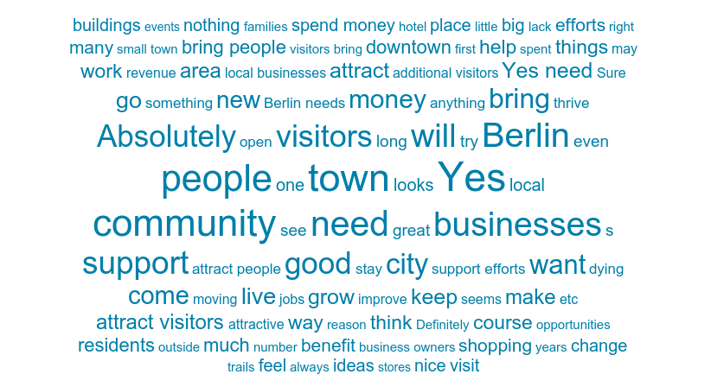

The following is representative of the recorded responses:
- Yes. The community is slowly dying because there is no reason to come here to shop. Ripon, Green Lake, Omro, Wautoma have figured out how to attract visitors so why can't this community?
- Yes. Always support new ideas, etc. from the younger generation
- Do NOT build a new motel. No one will come to a town that has nothing - waste of money and it will turn into low income housing or support convicts.
- If you are original, we attract visitors. Too many towns are copycats. One has old car shows, they soon all do. One has running, then they all do. If it is original, I would tend to support it.
- I support new ways out DO NOT tax people and then discard any new ideas. I have seen many "studies" be put on shelves and not acted on. That's a waste of money.
- We don't have nice parks
- Yes
- A hotel-convention center may be better placed on outskirts of Berlin but being placed in "town" would certainly bring the City more business! Dominos is s step -
- We need to get Berlinites to love and support Berlin before we can even worry about tourists! The school & City don't even shop local! If the Berlinites support Berlin, then worry about tourists.
- Yes - we need to attract more visitors & long-term taxpayers. Instead we seem to attract more people who deal with trouble/drugs, etc.
- Yes, with the loss of store fronts, there are fewer people paying property taxes
- Yes, the challenge is to keep things fresh, clean & in good repair so it looks like we care about what we have
- Yes, but seems to be dying - needs a lot of work - some beautiful buildings but in poor condition
- Absolutely, I know stuff costs - admire that Matt Chier & John Blazel really have stepped up with property they own.
- Of course - but help out the ones that are here too.
- This is mostly a bedroom community - only boutique kinds of businesses may draw from out of town
- This town in dying - bring in more attractive Retail like Ripon and Princeton.
- Yes! Even the possibility of the ATV Trail would bring more revenue...even if it is in the form of tickets, fuel, food and supplies.
- Do what works - Multiple sources of publicity-newspaper coverage, paid notices, radio, brochures posted on bulletin boards, discussion at all Council meetings and much more. Written warnings and finally, enforcement.
- Yes, I grew up in berlin and it would be great to see the community bridge the gap between generations
- Absolutely support it...100%. If people fall in love with the things to do in our town, they may want to move here. They may want to work here. They may want to start their own businesses here. Wouldn't that be great?
- Yes - more people visiting Berlin means more income for all businesses and in-turn, people will return if they have a good experience and place to come to.
- Yes, I would support that but rebuilding the community that works and lives here needs to come first or there is no reason to come here.
- Yes. We want people to come to Berlin to visit and spend money as long as they're quality people and not bringing a crime element.
- Absolutely - why would anyone NOT support this??
- "Of course I support these efforts because if our town looks better it’s good for visitors and for us who live here.
- Yes. Those that live here would like more and better shopping and eating opportunities (even fast food). Hopefully more visitors would help that (e.g. Wautoma).
- Yes, but it is more important to work to keep residents here than it is to attract visitors.
- Yes for the reason you mention. Brings dollars to the area.
- Yes.
- Absolutely. I'd be open for ANYTHING at this point. Quality visitors will impact our community greatly with increased revenue.
- I do support attracting visitors. But Berlin needs to be mindful of the impact on infrastructure. i.e. more traffic lights would be needed at key locations on Broadway St.
- Yes
- Advertise antiques
- yes, why not.
- Yes, visitors bring money to the community
- Yes as long as we keep the downtown historic buildings.
- Yes visitors will bring more money to the businesses to keep them thriving.
- "Yes to help merchants and meet people .
- No and I prefer no crowds.
- Yes, a busy local visitor economy is a must for any city to be able to sustain and hopefully grow
- ABSOLUTELY. I wouldn't have to leave town as much and when my family and friends’ cone to town we could spend the money here.
- I am not a resident so don't feel I should answer this question
- Yes, because it will create more revenue in our community to accommodate more events for families.
- Yes, anything that is going to get the word about Berlin out there is great. That way local businesses can stay afloat, and Berlin can give people and experience they haven't had yet to make them want to keep coming back.
- Yes bringing people to the area helps the economy both money wise and to expand everyone's world knowledge of things outside this small-town atmosphere...we are all part of a bigger world community...& How to Care about all peoples of the world.
- Yes
- The main street through town looks like a ghost town nights and weekends except for the bars. Walmart has driven most shops and stores from surviving.
- Absolutely... this is my home and I want it to thrive.

Question 5 : If you answered "no" what is your biggest concern regarding additional visitors?
- When kids graduate from High School, they will move away. Nothing here - So Sad - what have we done to our City - I would never buy property here - who knows when a new house of drug welfare people will move in.
- We don't have a grocery store on East side, very few job opportunities, few stores to attract visitors & prospective "customers" WE DON'T NEED A HOTEL!!
- More places to work to bring people in
- We don't need a motel if we can't even keep Berlinites in town. What we need is a grocery store - other than Walmart. Less welfare in Green Lake County
- That we may look run down and that no one cares, i.e. peeling paint, no benches on street for resting, cobwebs around doors/entrances and windows
- We seem to have attracted folks for our generous welfare - do not object to new folks if they contribute to our economy. Grew up in a time when 2 or 3 jobs helped us stay afloat and get ahead. It’s hard to find a young person willing to work. This is not only a Berlin problem, but society.
- Why would our young people stay in Berlin? Low income properties have brought in more crime, drugs and unkept homes.
- Right now I know for a fact half of Berlin goes to Oshkosh - drops off their dry cleaning goes next door to Festival Foods, hits Menards and drives back to Berlin. Wake up Mayor and City!!!
- How can you possibly think Berlin will survive without this...when this is taken seriously.change will come, until then, the community will continue to die.
- Recognizably a large undertaking, but one that has been long overdue and should have been started when ordinances were first being violated.
- Do people actually answer no to the above question? If so, that's a problem right there.
- I obviously answered "yes" but we may have to address parking down the road. But, that's a great problem to have. Plus, it would create more jobs in our area to actually construct parking lots. I pray we progress to enhance what Berlin has to offer. We can do this...together.
- The low- or no-income demographic of this town.
- Parking and higher crime rates
- crime, litter, noise, sex offenders, drunk drivers.
- My biggest concern is there is no visitors.
- Nothing to draw visitors here
- Lack of friendliness from people in town
- Depending on where they come from drugs coming to town
- why come back if there is nothing there????
- Seems as more and more riff raff moving here because of county benefits.
- Also the Rendering Plant and the smell repels people away, along with the Fox River contributing to the cess pool.
- Absolutely none...
- I do support it, but some of the reason I prefer the Christmas event in Berlin over Oshkosh is the smaller crowd.
- No concerns
- The quality of people berlin is attracting
- Drugs. We already have a problem here.
- Congestion.
- We don't need ATV's running on city streets!!!
- Visitors have been to Berlin but to be discouraged when here and vow to not return, but Berlin does have a draw that if these things would change, in time they would try the experience again.
- Crime
- pollution, losing the small-town connectedness feeling
- Low lifes, seems Berlin has more and more of this. Drugs!
- Overpopulation in too small an area
- Don’t bring visitors here just to get their drugs! What we have become with all the low income here! Sad!

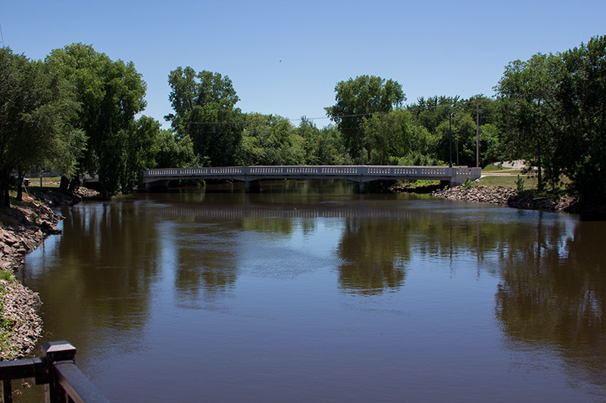

Common Themes in Visitor Perceptions
Visitors were approached at events, attractions, and businesses in Berlin during an 8-month period, 163 surveys were completed from Dec 2018 to July 2019. The visitor perceptions set the stage for community development and regionalism.
- The top assets mentioned by Visitors were Parks, Fox River, Shopping, Walmart, Pool, and Downtown
- Visiting family, friends, and relatives was a top reason for traveling to Berlin
- 33% reported that they were staying overnight
- The top requested needs were additional dining and shopping options.
Question 1 : Where do you live? (163 Arrivals)
Willow Springs, WI 1
Tomah, WI 1
Crivitz, WI 1
Little Chute, WI 1
Kenosha, WI 1
Pleasant Prairie, WI 1
Cambria, WI 1
Poy Sippi, WI 1
Adams, WI 1
Kenosha, WI 1
Stevens Point, WI 1

New Port Richey, FL 3
Chicago, IL 2
Brewton, AL 1
Tucson AZ 1
Long Beach, CA 1
Jacksonville, FL 1
Naples Manor, FL 1
Albany, GA 1
West Des Moines, IA 1
Charleston, IL 1
McHenry, IL 1
Plainfield, IL 1
Buffalo, MN 1
Lake Elmo, MN 1
Rochester, MN 1
Buffalo, NY 1
Doylestown, PA 1
Rucphen, Netherlands 1
Berlin, WI 30
Ripon, WI 13
Neshkoro, WI 12
Oshkosh, WI 8
Green Lake, WI 7
Wautoma, WI 4
Markesan, WI 4
Portage, WI 4
Omro, WI 4
Madison, WI 3
Fond du Lac, WI 3
Pine River, WI 3
Redgranite, WI 3
Wheatland, WI 3
Milwaukee, WI 3
Menasha, WI 2
Auroraville, WI 2
Waupaca, WI 2
Fountain City, WI 2
Neenah, WI 2
Princeton, WI 1
Montello, WI 1
Hortonville, WI 1
New London, WI 1
Marion, WI 1
Mosinee, WI 1
Wild Rose, WI 1
Fairwater, WI 1
Winneconne, WI 1
Watertown 1
Appleton, WI 1
De Pere, WI 1
Eureka, WI 1
Nepeuskun, WI 1
Fremont, WI 1
Marshall, WI 1
Brookfield, WI 1

Question 2 : From a visitor's perspective, what are this community's most attractive assets?
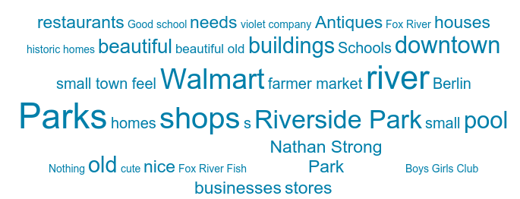
The following is representative of the recorded responses:
- Violet and Company
- Big old beautiful homes and violet and company
- Vintage shops
- Shops
- Shops, parks, festivals
- Violet and company
- Belissimo, violet & company
- Brick Buildings.sweet
- Nothing - No Business/No Grocery Stores except Walmart, No real Hotel/Motel
- Parks, River and Shelter houses
- The Park - East Side, Least Attractive - Local paper - "Police Reports", so much drug use and NO evidence of programs to reverse the problem
- My Parents
- Hospitals and Doctors
- The Senior Center, Jeff's on the Square, Bellisimo's and the Berlin Hospital. Walmart for some items. No other grocery store close unless you go to Wautoma, Ripon or Green Lake. McDonalds on occasion.
- Hamilton's - Lady Bug - Frank's Meats - Aquatic Center - Parks
- None
- Beautiful parks, nice Library, Swimming Pool (too cold) - Omro's is warmer with lots of people & classes for all, Hospital and Schools are wonderful
- Parks
- Mascoutin, pool, parks
- Riverside Park. Nathan strong park. Boys and Girls Club. Outdoor pool. Bellisimos.
- Uniqueness of buildings and old look
- River, park
- friendly people and small size
- The Parks
- Small, locally run shops, boutiques, venues that adhere to quality products and services
- the schools, riverside coffee company, violet & Co., parks, river
- downtown has huge potential need to fill with businesses that people want to browse and walk around. Park near downtown is beautiful. All of the old homes are too.
- Walmart and gas stations
- Fox river and fishing
- Coffee Shop
- Fox River and Fishing
- Beautiful old restored houses and buildings.
- Walkability (main drag), architecture, businesses near the river
- Quaint small-town feel.
- The river
- Cheap cost of living
- Fox River
- Sporting events, Mascoutin Golf course,
- Riverside Park, the clean streets , unique restaurants and stores.
- The Boys & Girls Club, a few small shops & Belisimo's
- We like the Farmers market and July 4th festivities. Riverside Park is fantastic.
- easily accessible shopping, beautiful older architecture in downtown
- Entering from the south to see and know how Badger Mining transformed a landfill into a business site, Hamilton's Ladies Wear, Dandelion Farm, Russell Moccasin, Berlin Buckskin
- My employer is located here.
- small businesses
- Nice Library, a few cute shops, the Italian restaurant, a festival or two. Nice Farmer's market.
- River
- The Historical shops and buildings. Definitely not the area by Walmart, the old pine mall, I think. Definitely needs a facelift. Total eye sore.

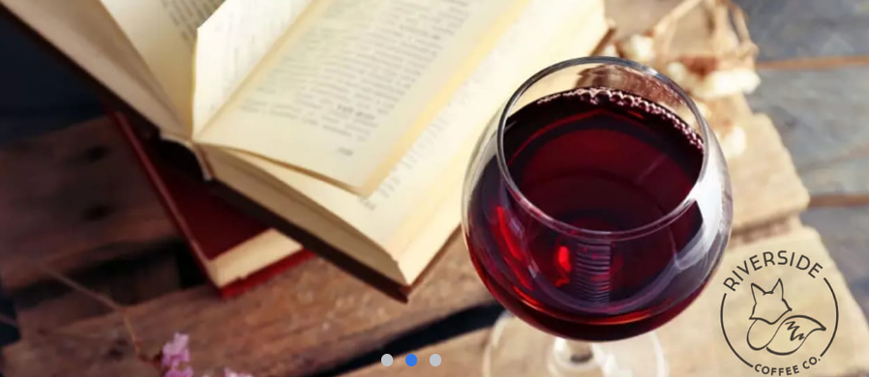
Riverside Coffee Company

Question 3 : What about this community encouraged you to visit today / staying overnight?
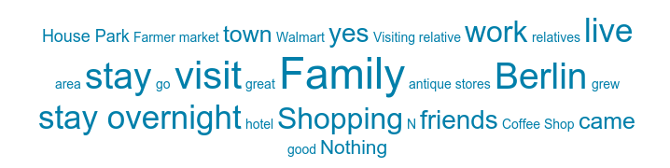
The following is representative of the recorded responses:
(“yes” denotes staying overnight)
- Violet and company
- In Green Lake
- Shop at Quinn's Market and Violet and Company
- There is no nice hotel to stay in Berlin. I came to check out the different stores in Berlin
- Yes, staying overnight
- Not staying overnight, Violet and company and Belissimo's
- Used to be Riverside Park, now dead trees & dirty bathrooms
- Not staying overnight, regular visits to the Nursing Home (Juliette Manor)
- Yes, Coffee Shop
- Not staying overnight, Restaurants and Walmart
- Not staying overnight, never have stayed overnight. Had lunch at Senior Center, play cards there every Friday, enjoy dinner at Jeff's occasionally and lunch at Bellisimo's
- Hamilton's - Lady Bug - Frank's Meats
- Not staying overnight
- Nothing
- Coffee Shop, I am staying in Ripon
- Community functions, car vs man (woman)
- Work in Berlin
- Yes, staying overnight, CUSA and visiting parents
- Yes with family
- Yes, visiting family
- Yes, my family
- Not staying overnight, open mic night at riverside coffee company
- Not staying overnight, open mic night
- Not staying overnight, work in berlin
- Not staying overnight, visiting a couple of businesses
- Yes, and family
- No appointment and coffee afterwards
- Not staying overnight, coffee shop
- Not staying overnight, appointment and coffee afterwards
- I have relatives that are In Berlin
- I visited end of April to early May for my 30th birthday to visit my grandma. My family is from Berlin, WI.
- The dandelion farm. Cemetery. Downtown. Did not stay overnight.
- Work
- Family , yes
- Nothing encourages me to stay overnight, or to visit frequently, other than my job is located here.
- I'll be at the Farmer's market tomorrow. Not staying overnight.
- This is a pass-thru town on my way to cottage, I usually get my groceries here so are freshest
- Shopping at Hamilton's Ladies Wear and Dandelion Farm
- Nothing; I come here solely for work.
- I work at Badger Mining Corporation.
- I usually come for farm market. Occasionally I come to Dandelion farm or the coffee house. I went to the Italian restaurant once and LOVED IT! Overall, we don't get out much :)
- Came in only to go to bank
- Not necessary for me because R retired and don't need anything but if I had to go into Berlin, I would go to the Dandelion shop
- Family
- Convenience and not as busy as other cities. Never stayed overnight.
- I live here and have since little
- Attended the Farmers Market. Didn't stay overnight.
- Dessert tasting at Baked. Did not stay overnight.
Question 4 : From your perspective, what are the community's most attractive assets?
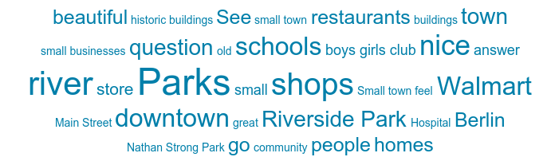
The following is representative of the recorded responses:
- Shops
- Beautiful homes
- Shops
- Fox river, parks
- The stores
- Love the downtown
- Violet and company and belissimo's
- Only Walmart & new School
- Not much - could certainly use a Grocery Store and decent Restaurant
- Some homeowners pride in their properties
- Memories
- Parks
- The Senior Center, Jeff's on the Square, Bellisimo's and the Berlin Hospital. Walmart for some items. No other grocery store close unless you go to Wautoma, Ripon or Green Lake. McDonalds on occasion.
- Aquatic Center - Parks
- All - empty store and house - let go BAD
- Beautiful parks, nice Library, Swimming Pool (too cold) - Omro's is warmer with lots of people & classes for all, Hospital and Schools are wonderful
- Multiple restaurants, places to eat
- homes
- beautiful parks, lovely houses, Tuesday farmers market, thrift store.
- small town
- well-kept downtown and main street area
- the parks
- friendly people
- sites of the town.
- Shepard’s and coffee
- River
- Shepard's and Riverside Coffee Company
- The beautiful park
- The river, and the possibility for lots of local/small businesses to open up.
- Same as the last time you asked this question.
- Nice downtown and the river
- Small Local Shops
- Golf Course
- Riverside Park, the clean streets , unique restaurants and stores.
- Riverside Park, Nathan Strong Park.
- Small town feel, beautiful older houses. The cemetery is awesome
- Entering from the south to see and know how Badger Mining transformed a landfill into a business site, Hamilton's Ladies Wear, Dandelion Farm, Russell Moccasin, Berlin Buckskin
- I know several people that live in Berlin; they are all excellent individuals.
- small businesses
- River. Cute unique shops. Unique restaurants.
- Parks
- Honestly not much
- Veterans park and riverside
- Just a quaint little old town
- River and parks
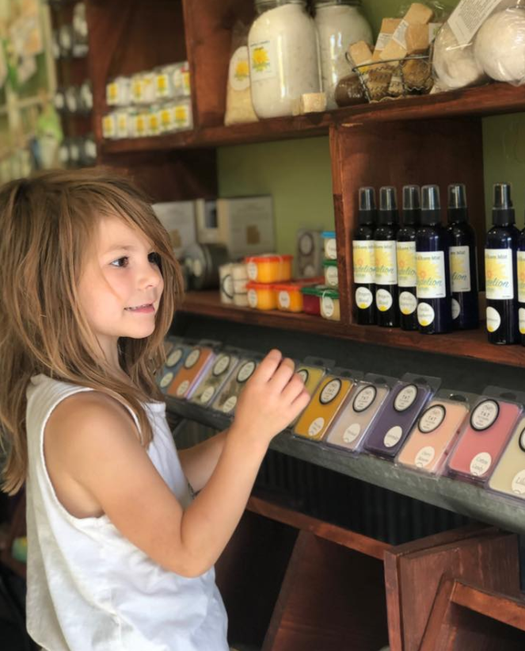
The Dandelion Farm
Question 5 : What are the community's greatest weaknesses in your eyes?

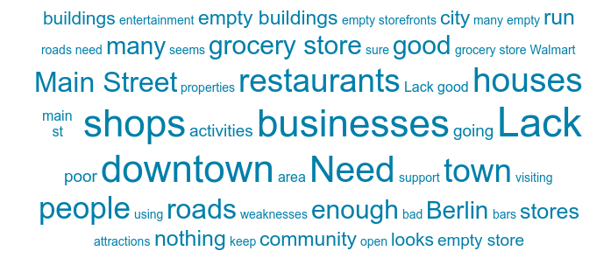

The following is representative of the recorded responses:
- Would be great if you could capitalize on the waterfront area with a river walk, eateries, and entertainment
- Road Construction
- Bad reputation to live
- The people in this town
- Few more shops would be nice
- Some shops closed downtown
- Rundown empty stores on Main Street. Visually bad houses
- Trashy yards - example, corner of Moore & Frontier. West side has many yards full of cars, junk, eyesore houses. Need cleanup or repair
- Inability for the City to keep a regular Grocery Store (Walmart does not count)
- Run down houses
- Main Street is dilapidated, lots of "vacancies" and "for sale", churches for sale for years. Greentree Mall is a disgrace, lack of a grocery store
- Senior Housing that people who do not need financial assistance can purchase - condominium units where yard care, snow removal etc. is provided
- No Grocery Store - would not buy any produce, meats or bakery from Walmart
- All - empty store and house - let go BAD
- Sad, Sad City!! This town has been ruined. It is a Welfare City. The sign is out! Houses are all run down - renters do not take care of property - Thank Advocap. Welfare people do not support - businesses, churches or volunteer.
- only 1 grocery store - Walmart;
- No plan or attempt to drive change. Allowing town to decline. Need reason to come - and spend to help local economy. it is just another dying town. try something different.
- Lack of downtown. Poorly kept properties.
- Bad roads
- Roads are in need of repair
- Roads
- More options to cater to 18-24, 25-34 ages. Paired with more involvement of 18-34 aged people
- Lack of affordable housing
- Empty shops downtown
- Empty storefronts, not enough inters testing stores that make me want to just wonder the street. more nice casual dining options.
- Unused storefronts
- Empty buildings
- Need more
- Unused storefronts
- The lack of store front being used
- Not much to do unless there’s an event.
- Empty buildings on main street, no outdoor seating on main street at restaurants and such.
- Lack of diversity/amenities.
- Empty Storefronts, Crime, Drug Activity
- Not enough summer events.
- I don’t believe there are any weaknesses as a visitor. You have the necessities for a small town
- No vision for growth/revitalization, an abandoned downtown area, lack of adequate housing, no sense of community/pride. The town is not thriving, it is stale and lifeless.
- Lack of unique restaurants- especially Supper Clubs. The Downtown is run down and unattractive.
- Urban blight, not uncommon when big chain stores enter the picture
- No attractions. No place to hold a wedding reception, conference. A mayor who doesn't support growth.
- No decent restaurants or hotels.
- small business support
- Some interesting people....but all communities have them. Also gas is very far to the west if you come to town.
- Dead mainstreet
- Downtown is dirty. Too many bars and junk stores
- Allowing Walmart to drain the town, and it appeared as if no improvements are being done to the mall area, looks like a picture from Eastern Europe.
- Downtown
- Lack of shops and restaurants and Eskimo comfort is an eyesore
- The poor condition of main street road downtown. Awful.
- Restaurant and fast food choices

Question 6 : What addition to this community would make it more likely that you'll return?

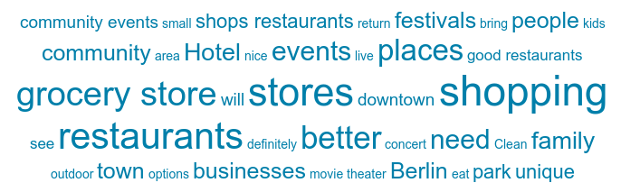

The following is representative of the recorded responses:
- More great shops like violet & company
- More wineries
- More places to shop, restaurants
- Build hotel, add to the community have more stores and businesses
- Few more shops
- Another little bistro
- Repair Street downtown, another grocery store, less on again-off again Thrift Shops
- Shepards opening year round
- Walking paths, bridges along the River
- More fast food restaurants and general family restaurants
- Condominium Units for Seniors not needing Financial Aid
- Grocery Store, Bakery, Dry Cleaners, Children's Clothing Store, Home Goods and Restaurant
- Clean up House - need a Grocery Store
- Downtown scene. More shopping. A brew pub / more dining options.
- More places like Starbucks, culvers, etc.
- Parties in the park
- More restaurants
- Long john silvers and dunkin donuts
- Events catered to the younger ages
- Target or other shopping
- More festivals
- family
- Shepard's
- More festivals
- Possibly more Festivals
- I spent a lot of time in Berlin because of my family and will continue coming back to see them. But with businesses like Riverside Coffee and House on Park - I definitely see coming back to also spend more time and money.
- I will always return.
- Make main street appeal to the eye. Fix things up and get the buildings filled.
- More places to eat, and more activities.
- Aldi Grocery Store
- A few good Restaurants, and more outdoor events in the summer.
- None, I will be returning !
- More restaurants, life/activity in the downtown area, family events and unique shops to bring people to town.
- Better, unique places to shop for clothing, gifts and groceries. Ripon is a prime example of this.
- A real grocery store, not a quickie-mart, or discount store
- Boutiques, similar to Ripon where you can walk up and down the streets to shop and eat.
- I'll continue to come here regardless of changes or additional attractions because this is where my employer is located.
- Small businesses - the heartbeat of small communities
- I'd buy groceries there is it were more convenient instead of going into Oshkosh from Eureka. I don’t know about hotels or B&Bs as I don't need to stay overnight.
- Unique stores
- A real grocery store. Some actual good restaurants
- A brewery would be great, definitely be an improvement from the 5+ Bars. It’s just sad how it feels Berlin has been neglected and worn down with little to no improvements on existing buildings. Definitely needs a little TLC and I’m sure she’d spruce back up!
- reason to come and stop and shop.
- By adding more little fun stores or shops to go through
- More shops and restaurants
- Splash pad, very nice park for smaller kids, maybe more diversity of restaurants with outdoor seating for summer.
- Fast food styles, dog park or area, more apparel available to buy
- Unique shopping & dining experiences. Violet and Company is a great example. A Chamber of Commerce is greatly needed for any economic growth.
- Unknown
- Hotel. Sense of togetherness or support.
- Food with outside dining....weekend music through the summer ...the marketplace is cool but, on a Tuesday, makes it hard for people that work

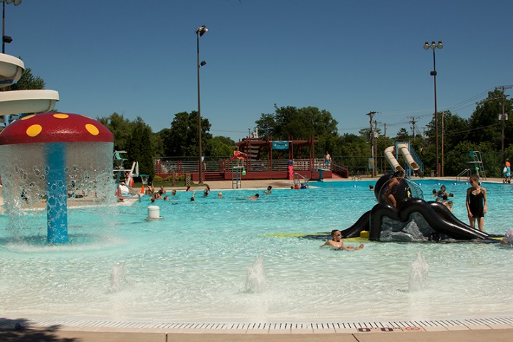

Berlin Aquatic Center

Destination Asset Summary

Local = Drawing residents only
Regional = Day trips; visitors coming short distances from around the area
Destination = May prompt an overnight

Residents and stakeholders participated in a process to inventory assets in Berlin, and the Green Lake County area. The following list complied at a facilitated discussion at Goodrich Furniture on April 23, 2019.

Restaurants - Mexican, Italian, American, Fast Food, Supper Club, Subs, etc.
Bars / Taverns
Coffee Shops
Antiques
Parks - Picnics, Events, Memorials
Aquatic Center
Bowling Alley
Museum
Library
Senior Center
Boys and Girls Club
Shopping - Walmart, Furniture Store, Clothing Store, Show Store, Floral Shop, Hardware Store
Oldest Shoe Store (in Wisconsin)
Beauty Salon / Barbers
Gyms / Fitness Clubs
Boot Company
Specialty Shops - Soap, Bike Shop, Hunting Shop,
Churches
Healthcare - Local Pharmacy, Walmart Pharmacy
Riverway - Fishing, Kayaking, Canoeing, Boating,
Golf
Trails - Biking, Snowmobiling, Hiking, Mascoutin Valley Trail
Convenience Stores
Schools
Service Clubs
AgTourism - Farmers Market,
Events - Music in the Park, Car Show, July 4th Parade, Taste of Berlin, Fishing Tournament, Trees in the Park, Ghost Walk, Walleyes for Tomorrow, Cancer Walk, Garage Sales, Shop Hop, Small Business Saturday, EAA (proximity)
Sports / Sporting Events
Bakery
Butcher Shop
Safe Community / Public Safety
Camping
Lodging / B&Bs
Gun Club
Local Media / Newspaper
Manufacturing / Industry / Production - Ripon, Aurora, Wisconsin Spice
Retirement Homes
Car Dealers / Auto Service
Public Transportation - Cab Service, Bus Service
Green Lake County – Central Location
Transportation Corridors
Historic - Architecture, Cemetery, Parks, Military, Memorials

Berlin’s Top Tourism Assets

Ranked by the participants/stakeholders during public meetings and discussions:

Top Assets
- Events
- Camping – B&Bs
- Shopping (Big Box / Local / Specialty)
- Parks
- Trails (Land and Waterways)
- History (Military, Cranberries)
- Activities (Sports, Golf)

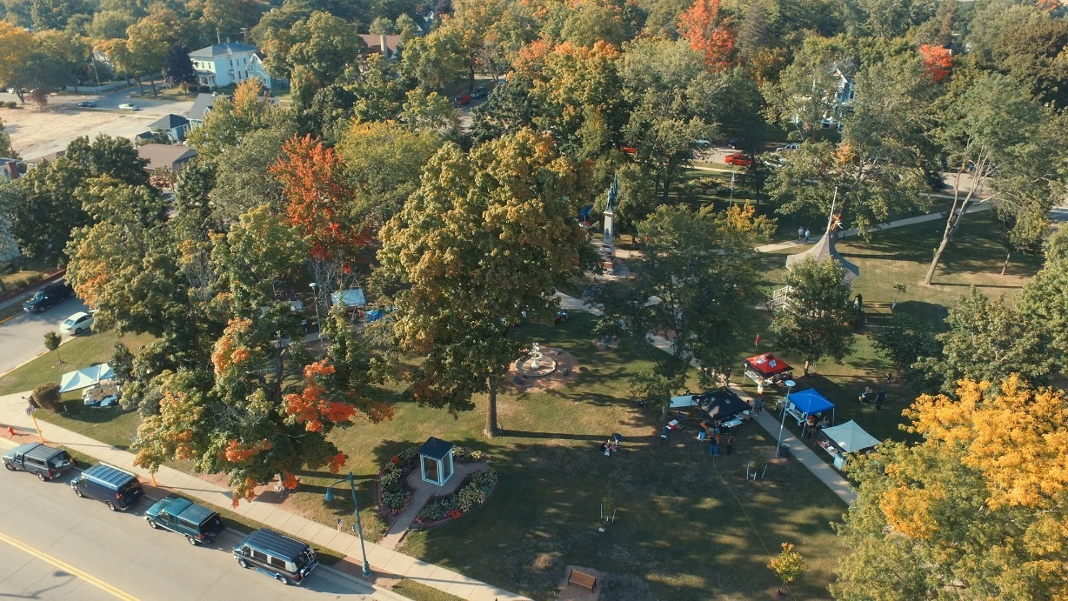
Competitive Overview: Win, Lose, Draw
This is an exercise to analyze how Berlin fares against the competition reflecting on the assets as being better, the same or inferior.

Berlin competitive market: Green Lake
 | Win | Lose | Draw
- Events |  |  | X
- Camping – B&Bs |  |  | X
- Shopping | X
- Parks |  | X
- Trails (land and Waterways) | X
- History (Military / Cranberries) |  |  | X
- Activities (Sport / Golf) |  | X

Berlin competitive market: Ripon
 | Win | Lose | Draw
- Events |  | X
- Camping – B&Bs |  | X
- Shopping |  | X
- Parks |  |  | X
- Trails (land and Waterways) |  |  | X
- History (Military / Cranberries) |  | X
- Activities (Sport / Golf) |  | X

Berlin competitive market: Princeton
 | Win | Lose | Draw
- Events | X
- Camping – B&Bs |  |  | X
- Shopping | X
- Parks |  |  | X
- Trails (land and Waterways) |  |  | X
- History (Military / Cranberries) | X
- Activities (Sport / Golf) |  |  | X

Strengths, Weaknesses Opportunities, Threats (SWOT)
Strengths  Affordable community  Small town charm  Proximity to family  Proximity to larger towns  Unique architecture  River  Parks  Pool  Community services  Good schools  Many services clubs / non-profits | Weaknesses  Empty Storefronts  Perceived drug problem  Truck traffic in town- Busy on 49  Old ideas, not willing to change  Age of residents, need to attract younger people  Walkability in downtown  Curb appeal  Heavy industrial climate  Chamber of commerce weak  Funding for promotions  Businesses not collaborating on promotions  Hours of operational (5pm / Sundays)  Pedestrian / Biking acceptance  Lodging quality
Opportunities  Good traffic on 49  Willingness to promote events  River  Community services  Pool  Many service clubs/non-profits hold events  - Lions Club (Rose sales, Coupon books)  - Kiwanis (BBQ chicken dinner)  - ABC Group (July 4th)  - History Museum (Ghost walk)  - Boat Club (Corn roast)  - Car Club (car show)  - Friends of Library  - Friends of Berlin Parks  - Friends of Senior Center (Thanksgiving dinner)  - Berlin Bugle Mouth Bass (Fishing tournament)  Downtown curb appeal, small town charm  Support of City of Berlin  Funding from industry/businesses for marketing | Threats  Truck traffic downtown  Walkability, need crosswalk signage/lights  Support from City Council  Funding  Lack of PR  Weak chamber of commerce

BERLIN TOURISM / MARKETING OPPORTUNITIES SUMMARY
RANK:  TOPIC-  ITEM | RATING:  EASY, MEDIUM,  DIFFICULT | TIMELINE  FOR  COMPLETION: | COMMENTS/CONCERNS: | OWNERSHIP:
- Great Customer Service  and Hospitality  Grow Berlin Community Pride | EASY - MEDIUM | START ASAP;  6 Months;  Updates regularly | Presentations / Workshops  Consultations with Wisconsin Department of Tourism
- Inventory | EASY - MEDIUM | COMPLETE | Need to compile list of promotable assets | COMPLETED for report, advise continuing to gather as ongoing marketing data
- Surveys |  | COMPLETE | Need to register perceptions and opinions of residents, stakeholders, visitors to gauge promotional direction | COMPLETED for report, advise continuing to gather as ongoing marketing data
- Mission and Vision | EASY - MEDIUM | START ASAP;  regular updates and ongoing | Berlin needs a plan for moving forward as a community | Suggested in report
- Marketing and  Media Plan | MEDIUM | START ASAP | Plan all community marketing using a monthly/quarterly calendar
- Travel Guide – Print Material | MEDIUM | ONGOING | Fun on the Fox  Discover US | Berlin Journal Newspapers
- Social Media Plan | MEDIUM | START ASAP;  6 Month updates | Coordinate with local businesses and events
- Promotional Materials | MEDIUM | START ASAP;  One year and updated yearly | Build “Berlin” branded template for event promotions
- Community PR | EASY - MEDIUM | START ASAP;  regular updates and ongoing | Regular messaging to residents and stakeholders about the importance of tourism as it relates to economic development efforts
- Chamber of Commerce | CHALLENGING |  | This is the time for serious discussion about what this organization should look like. | Business, Economic Development, and Tourism
- Curb Appeal - Beautification | CHALLENGING | ONGOING | Find ways to improve appearance of facades, storefronts, signage, crosswalks, etc.
- Events | MEDIUM | START ASAP;  6 MONTHS | Build “Berlin” branded template for event promotions.  Explore ideas for new events / expanding current events that align with Berlin’s vision and drive downtown traffic and nights/weekends. | One lead person PER current event in Berlin
- Event Development | MEDIUM | START ASAP;  regular updates and ongoing | Explore new ideas for events in Berlin based on local unique inventory  (IE: Stinky Shoe)
- Regional Collaboration | MEDIUM | START ASAP;  6 MONTHS | Find ways to partner with marketing efforts in surrounding schools and communities

Destination Mission and Vision Summary
What is a destination? A destination is essentially the ending point for any trip. There as many different types of destinations as there are communities for people to visit. The important point is that you know who you are and what kind of destination assets you have that will appeal to your visitors and potential visitors.

The residents and stakeholders envision a strong potential for Berlin and were optimistic about the future of this small community. Overwhelmingly, the city supports finding ways to grow economic development and tourism, especially in finding ways to attract more visitors and workforce.
It is suggested to draft a Destination Mission and Vision for Berlin, Wisconsin:
MISSION
Offer Berlin, Wisconsin as a tourist, cultural and natural destination that promotes sources of growth for economic, social and sustainable development of its inhabitants.
VISION
Berlin, Wisconsin is recognized, nationally and internationally, as a unique sustainable tourist destination, which promotes social, economic and environmental development, responsible for the benefit of its residents and visitors.
Destination Vision and Marketing Recommendations
Develop a Diversified and Scheduled Marketing Plan
- Every tourism marketing effort should begin with a solid plan, one that includes not only a budget, but a defined plan utilizing a monthly or seasonal calendar. The marketing plan is your road map and details the attractions and events in your area. At the end of each tourism season, you can use your marketing plan to set goals and make changes for next year. For example, if revenue at one attraction did not meet expectations, perhaps it needs product development, some upgrades to make it more appealing to visitors, or better advertising.
- Take advantage of earned media opportunities. Local events, and even larger regional events involve significant media coverage. Explore ways to expand messaging that will include activities in Berlin as a complimentary option for visitors.

Develop a “First Impressions” program and a thriving Berlin
- Highlight the human side of your destination and build trust with the people exposed to it.
- First impressions include many elements such as your commitment to customer service. Most businesses believe they provide exceptional customer service, but truth be told, this is not always the case. Work with your Regional Tourism Specialist to craft customer service sessions that meet your needs.
- A strong component of Berlin’s development vision should focus on improving Berlin’s approach to welcoming visitors, those customers “we haven’t met yet”. Businesses have a strong following with local and regional customers and the perception of small-town atmosphere was very prevalent at the local level.

Create “Themed Itineraries” to Utilize the Existing Strong Traffic Patterns and the Natural Assets of Berlin.
- Berlin is well situated on Highway 49 and Highway 91, corridors with heavy traffic, and located midpoint between Highways 21 and 23.
- The itinerary concept can be used to include tourism assets not located in Berlin to highlight those that are. Positioning Berlin as an addition, or even an option to other larger regional destinations will require collaboration with promotional efforts in Ripon, Green Lake, and Redgranite.
- Merge branding signage, maps and information (printed guides, itineraries, web content and mobile applications into a cohesive program to move people around the region and capitalize on the theme of the destination. By offering numerous points of interest and places for people to purchase services and amenities, the opportunity to convert daytrip visitors into overnight guests greatly increases.
- Themed itineraries utilizing natural assets (trails, parks, waterways) while including culinary and an artisan collective approach will drive extended visitor durations.
- Continue to develop cross promotional opportunities with Ripon and all of Green Lake County focused on outdoor recreation.

Leverage Popularity of Effective Local Events to Promote Berlin Attractions
- Local events, including very strong holiday events, are regionally renowned. The participation of local attractions should be paramount. This will promote Berlin as a destination for many different interests.
- Consider the role of attractions during events, and possibly have satellite events taking place at specific locations during large events at no extra charge, such as offer tours and have artisan related programs/activities available.
- Continue to explore ways to integrate nature-based attractions and retail opportunities in the area.

Social – Visual – Digital
- Show off what makes you unique on social media, every destination has something special that nobody else does. Ask yourself “Can my online audience see what we do?”. While it is evident that Berlin regularly shares tourism related information via social media, engagement from businesses should be equally active.
- Social media produces high engagement, especially for travel brands. In your tourism marketing strategy, it is recommended to invest more in the mechanics of gaining more active followers.
- Grow social platforms, such as Facebook, Twitter, and Instagram via engagement with followers. Respond with relevant feedback and active native content.
- Social media has made a huge impact on the tourism industry. Consumers engage with social networking sites to research trips, make informed decisions about their travels and share their personal experiences of a particular hotel, restaurant or airline.
- Create awesome destination videos. The online world is moving toward short form videos, with 6 and 15 second videos now commonplace. Videos convey a huge amount of information in very little time, so it’s a great way to showcase who you are and what you do. Show people your destination and help them out at the same time. Create helpful videos that showcase things to do in your area, helpful tips about getting around, fun facts, and locals-only secrets. Share these videos on your website and social media.

Implement a “Shoulder Season” Content Strategy
- Regardless of when people choose to travel, they are dreaming of their next vacation all year round. Leading up to the slow season, publish native content and blog posts that are centered around experiences they can enjoy in your region during the off-season.
- Start with brainstorming a list of experiences that people will enjoy, addressing any fears (too cold, too wet, too hot, too humid, etc), and reiterating the experience benefits.
- Get out and about in the Berlin area and take some photos and videos of those experiences, during the low season (so people can see real-time what it’s like at that time of year).
- Optimise your social posts that relate to the content, to ensure it gets maximum visibility in search engine results when people are typing in relevant search queries into Google.
- Encourage all businesses and attactions to share your posts with their social and email communities, and make sure you re-share it during your peak and shoulder season to drive demand before you hit the shoulder season.
Re-engage Your Locals & Offer Special Deals for Loyal Customers
- There is merit in offering your locals and loyal customers a special deal if they visit and stay with you during the shoulder season or slower dayparts. Consider a mid-week accommodation special or throw in a unique/tailored experience for any bookings throughout the shoulder period. Promote your local/loyal customer deals via a targeted marketing campaign and ensure you track the return on investment of the campaign to measure effectiveness and growth.

- VFR (visiting friends and relatives) travel involves visitors whereby the purpose of the trip or the type of accommodation involves visiting friends and/or relatives. Your local community is the source for all of your VFR customers and there are opportunities in offering a promotion to this segment via a geographically targeted social media, or even via a segmented email marketing campaign. Remember to include details about the local economic importance of the “shop local” segment.

*************

CREDITS and REFERENCES

Berlin Farmers & Artists Market
City of Berlin
Riverside Coffee Company
Tracy Rhodes - Klawitter's Photos
Berlin Aquatic Center
The Dandelion Farm
Letter from Daniel Hoppa
https://cityofberlin.net/
https://www.travelwisconsin.com/central/green-lake-county/berlin
https://berlinchamber.net/
https://bestfarmersmarkets.org/place/berlin-farmers-and-artists-market-berlin-wi.html
https://www.rogerbrooksinternational.com/
http://www.co.green-lake.wi.us/
http://www.riponmainst.com/riponmainst/
https://www.cityofripon.com/

